CI/CD for Node.js Retail App

  - Course Name: DevOps Foundation

Institution Name: Medicaps University – Datagami Skill Based Course

Student Name(s) & Enrolment Number(s):
Sr no | Student Name | Enrolment Number
1. | YASH RATHOD | EN22CS3011109
2. | YASH CHOUDHARY | EN22CS3011099
3. | VISHU AGRAWAL | EN22CS3011093
4. | YUVRAJ KACHHAWA | EN22CS3011124
5. | PRIYA SATPUTE | EN22ME304072

Group Name: G08-D10
Project Number: DO-21
Industry Mentor Name:
University Mentor Name: Prof. Avnesh Kumar Joshi
Academic Year: 2025-26

Problem Statement & Objectives

- Problem Statement

In modern retail applications, frequent updates, feature enhancements, and bug fixes are required to meet customer demands and stay competitive. Traditional software development and deployment methods are manual, time-consuming, and prone to human errors. These issues often lead to delayed releases, inconsistent application performance, downtime, and security vulnerabilities.

For a Node.js-based retail application, managing code integration, automated testing, and reliable deployment across environments (development, staging, production) becomes challenging without a structured automation pipeline. The absence of Continuous Integration and Continuous Deployment (CI/CD) practices can result in:
- Integration conflicts between developers
- Deployment failures
- Increased production bugs
- Slow release cycles
- Reduced customer satisfaction

Therefore, there is a need to implement a CI/CD pipeline that automates building, testing, and deploying the Node.js retail application to ensure faster, reliable, and secure software delivery.

- Project Objectives

The main objectives of implementing CI/CD for the Node.js Retail App are:
- Automate Code Integration
Automatically integrate code changes into a shared repository using version control tools like Git.
- Implement Continuous Testing
Automatically run unit and integration tests whenever new code is pushed to ensure code quality.
- Enable Automated Builds
Generate application builds automatically after successful code commits.
- Achieve Continuous Deployment
Automatically deploy the application to staging and production environments after passing all tests.
- Improve Application Reliability
Reduce manual errors and ensure consistent deployment across environments.
- Reduce Deployment Time
Speed up release cycles and deliver features to customers faster.
- Enhance Monitoring and Feedback
Provide quick feedback to developers regarding build failures or test errors.
- Ensure Scalability and Security
Integrate containerization (Docker) and cloud deployment to ensure scalable and secure infrastructure.

- Scope of the Project

The scope of this project includes designing and implementing a complete CI/CD pipeline for a Node.js-based retail web application.
In Scope:
- Setting up a Git-based version control system
- Configuring CI tools (e.g., Jenkins / GitHub Actions / GitLab CI)
- Automated testing using frameworks like Jest or Mocha
- Automated build process
- Docker containerization of the Node.js app
- Deployment to cloud platforms (AWS / Azure / Heroku)
- Environment management (Dev, Test, Production)
- Monitoring basic deployment logs and pipeline status

Proposed Solution

Key Features
- Automated code integration using Git
- Continuous Integration on every code commit
- Automated unit and integration testing
- Automatic build generation
- Docker-based containerization
- Continuous Deployment to staging and production
- Environment-wise configuration management
- Automated rollback mechanism
- Real-time build and deployment status monitoring
- Secure credential and secret management

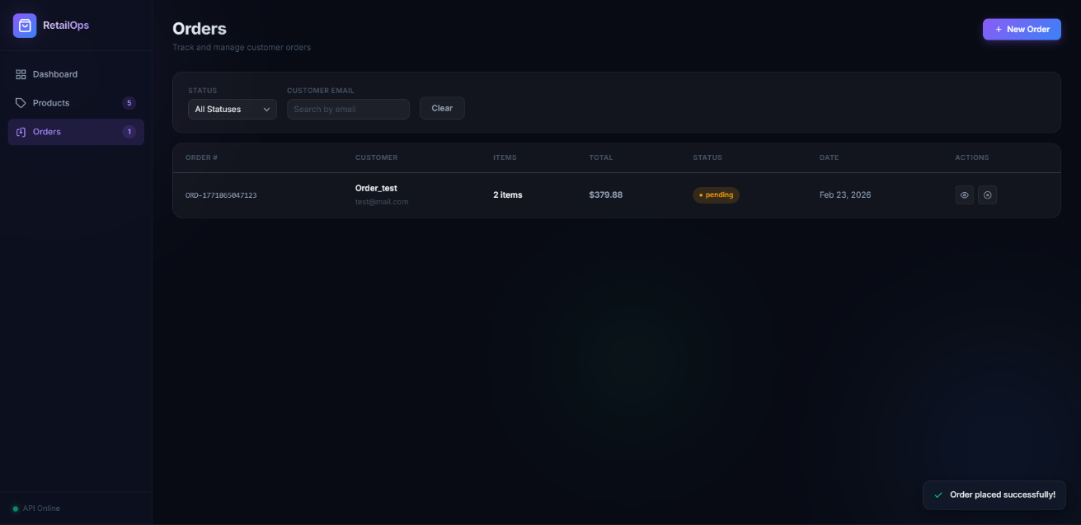

Overall Architecture / Workflow

The proposed solution implements a structured CI/CD pipeline for the Node.js Retail Application to automate the complete software delivery lifecycle.

Developer
↓
Git Repository (Source Code Management)
↓
CI Server (Build & Test Automation)
↓
Docker Build & Image Creation
↓
Container Registry
↓
Staging Environment Deployment
↓
Production Environment Deployment
↓
Monitoring & Feedback System

Step 1: Code Development
Developers write code for the Node.js retail application and push changes to a centralized Git repository (e.g., GitHub).
Step 2: Continuous Integration (CI) Trigger
Whenever new code is pushed:

- The CI tool automatically triggers the pipeline.
- The latest code is pulled from the repository.
Step 3: Build Stage
- Install dependencies using npm.
- Perform code linting.
- Generate application build artifacts.
Step 4: Testing Stage
- Execute automated unit tests.
- Run integration tests.
- Validate test coverage.
If tests fail → pipeline stops and notifies developers.
If tests pass → move to next stage.
Step 5: Dockerization
- Build Docker image of the Node.js application.
- Tag the image with version number.
- Push image to Docker registry.
Step 6: Deployment Stage
- Deploy containerized application to staging environment.
- Perform basic smoke testing.
- If successful, deploy to production environment.
Step 7: Monitoring & Feedback
- Monitor logs and application health.
- Notify developers in case of failure.
- Maintain version history for rollback if required.

Tools & Technologies Used

Programming & Framework
- Node.js
- Express.js
- npm
Version Control
- Git
- GitHub
CI/CD Tools
- Jenkins / GitHub Actions / GitLab CI
Testing Frameworks
- Jest / Mocha / Chai
Containerization
- Docker
- Docker Hub
Cloud / Deployment Platforms
- AWS EC2 / AWS Elastic Beanstalk
- Heroku
- Azure App Service
Monitoring & Logging
- PM2
- GitHub Actions logs
- Jenkins dashboard

Results & Outputs

The implementation of the CI/CD pipeline for the Node.js Retail Application successfully automated the build, test, and deployment process. The following results were obtained after executing the pipeline.

Reports / Dashboards / Models

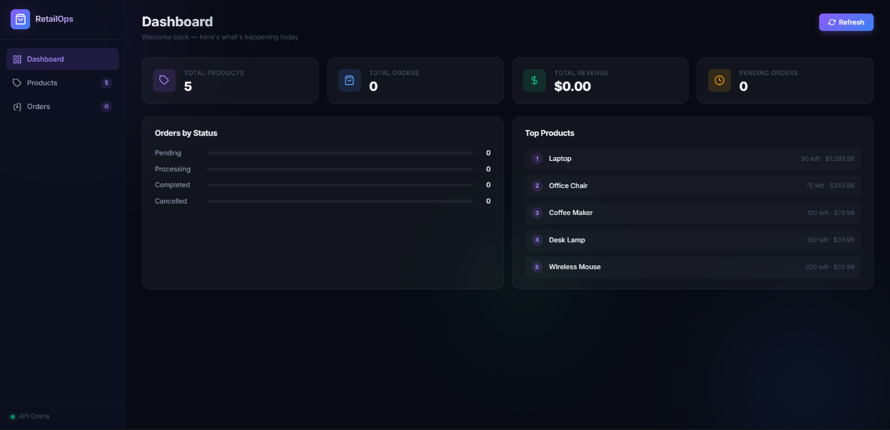

1. CI/CD Dashboard
- Build history report.
- Pipeline execution time.
- Success vs Failure rate.
- Real-time build monitoring.
2. Code Quality Report
- Code coverage percentage.
- Static code analysis results.
- Lint error report.

3. Deployment Report
- Version number deployed.
- Timestamp of deployment.
- Environment details (Dev / Staging / Production).
4. Monitoring Dashboard
- Application uptime status.
- CPU & memory usage (if deployed on cloud).
- Container health check logs.
5. Model Used
The project follows:
- Continuous Integration Model
- Continuous Deployment Model
- DevOps Lifecycle Model (Plan → Code → Build → Test → Release → Deploy → Monitor)

Key Outcomes

After successful implementation of CI/CD for the Node.js Retail App, the following outcomes were achieved:
- Reduced Deployment Time
Deployment time reduced from manual process (30–45 minutes) to automated process (5–10 minutes).
- Improved Code Quality
Automated testing ensured early detection of bugs.
- Zero Manual Deployment Errors
Automation minimized human mistakes.
- Faster Feedback to Developers
Immediate notification on build or test failure.

- Improved System Reliability
Stable and consistent deployments across environments.
- Better Version Control
Easy tracking of changes and rollback capability.
- Scalable Deployment
Docker-based deployment made the application portable and scalable.

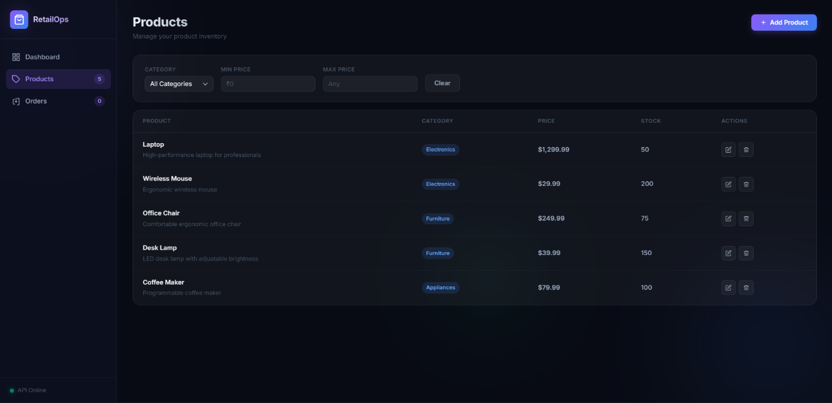

Conclusion

The project on CI/CD for Node.js Retail Application successfully demonstrated the implementation of an automated software delivery pipeline that integrates Continuous Integration and Continuous Deployment practices. The primary objective was to eliminate manual build and deployment processes and replace them with a structured, automated workflow. By integrating version control, automated testing, containerization, and cloud deployment, the project ensured faster, reliable, and consistent releases of the retail application.

The CI/CD pipeline streamlined the development lifecycle by automatically building the application, executing tests, generating Docker images, and deploying the application to staging and production environments. This significantly reduced deployment time, minimized human errors, and improved overall application stability. The integration of testing frameworks enhanced code quality, while monitoring and logging mechanisms provided real-time feedback on system performance.
Through this project, key learnings included practical understanding of DevOps principles, Git-based version control, pipeline configuration, Docker containerization, automated testing, and deployment strategies. It also provided hands-on experience in handling real-world development challenges such as build failures, environment configuration, and deployment troubleshooting.
Overall, the project highlights the importance of CI/CD in modern software development and demonstrates how automation improves efficiency, scalability, reliability, and product quality in a Node.js-based retail application.

Future Scope & Enhancements

Although the CI/CD pipeline for the Node.js Retail Application has been successfully implemented, several improvements and advanced enhancements can be incorporated in the future to make the system more scalable, secure, and production-ready.

Future Scope

- Microservices Architecture
The current application can be transformed into a microservices-based architecture for better scalability and independent deployments.
- Kubernetes Integration
Instead of basic Docker deployment, container orchestration using Kubernetes can be implemented for automated scaling, load balancing, and high availability.

- Advanced Cloud Infrastructure
Infrastructure-as-Code (IaC) tools like Terraform or AWS CloudFormation can be used to automate cloud resource provisioning.
- Blue-Green / Canary Deployments
Advanced deployment strategies can be introduced to minimize downtime and reduce deployment risks.
- Automated Security Scanning
Integration of security tools for vulnerability scanning, dependency checking, and container security.
- Performance Testing Automation
Adding load testing and stress testing stages in the CI/CD pipeline.
- Multi-Environment Deployment
Expanding the pipeline to handle multiple production regions for global retail applications.

Enhancements

- Integration with Code Quality Tools
Tools like SonarQube can be integrated for static code analysis and quality gates.
- Automated Rollback Mechanism
Implement intelligent rollback in case of deployment failure.
- Monitoring & Alerting System
Integrate monitoring tools like Prometheus and Grafana for real-time performance tracking and alerts.
- Continuous Delivery for Mobile App
Extend CI/CD to support mobile retail applications (Android/iOS).

- AI-Based Deployment Insights
Implement analytics to predict deployment risks and optimize release cycles.
- DevSecOps Implementation
Integrate security checks at every stage of the pipeline to enhance application security.
- Scalable Database Deployment
Add automated database migration and backup strategies.

